SWIGGY SALES ANALYSIS USING MICROSOFT SQL SERVER
PROJECT DOCUMENT
1. Data Cleaning & Validation
To Ensure raw dataset is accurate, consistent, and ready for analytical modeling.
Null Value Check :
Checked all business-critical columns (State, City, Order_Date, Restaurant_Name, Category, Dish_Name, Price, Rating) for missing values.
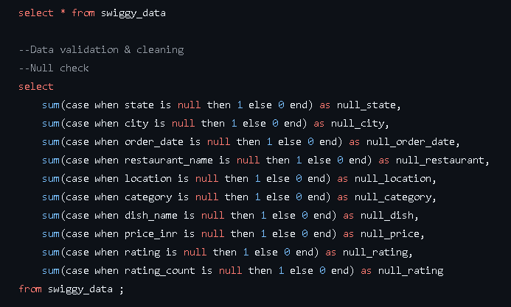
Blank String Check :
Validated empty string entries to avoid incorrect aggregations.
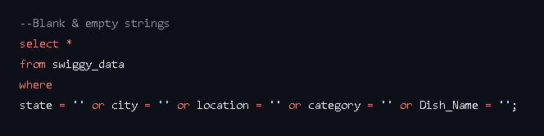

Duplicate Detection :
Identified duplicate rows using group by + having count(*) > 1
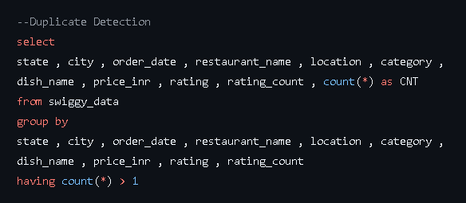
Duplicate Removal :
Removed duplicates using row_number() window function while retaining one clean record
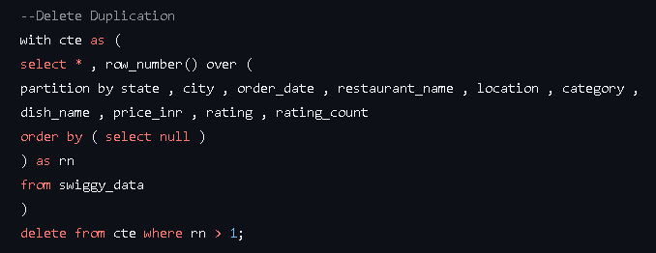
Outcome :
- 29 duplicate rows removed
- No null or blank inconsistencies affecting KPIs
- Dataset ready for dimensional modeling
2. Dimensional Modeling – Star Schema
What is Star Schema ? - A Star Schema is a data model where a central Fact Table (containing measurable data like orders and revenue) is connected to multiple Dimension Tables (like Date, Location, Restaurant, Category, and Dish). This structure makes data easy to analyze, scalable, and efficient for reporting.
3. Dimension & Fact Table design :
Fact Table : fact_swiggy_orders
Stores measurable metrics:
- Price_INR
- Rating
- Rating_Count
Each row represents one order transaction.
Dimension Tables :
- dim_date → Time attributes
- dim_location → State, City, Location
- dim_restaurant → Restaurant details
- dim_category → Cuisine type
- dim_dish → Dish name
Dimensions provide descriptive context to fact data.
ERD Diagram : Star Schema
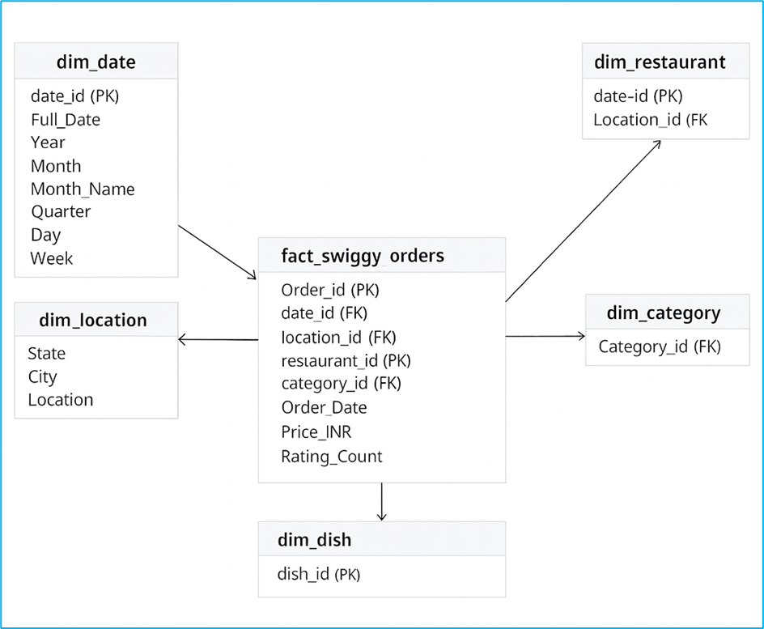
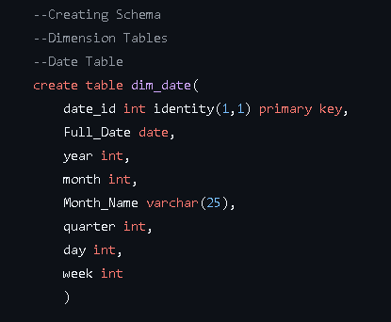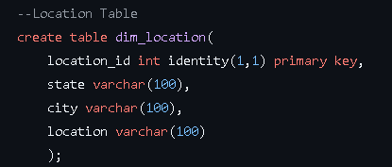
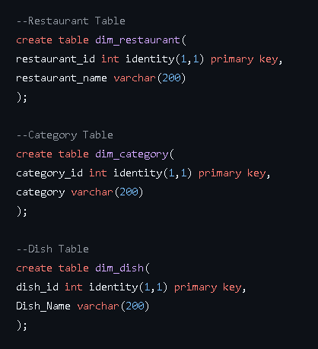
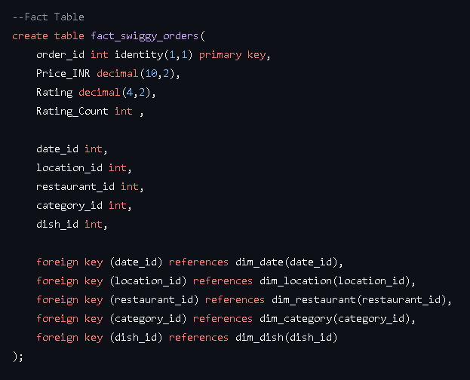
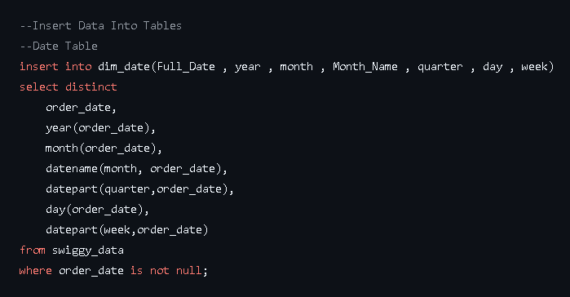
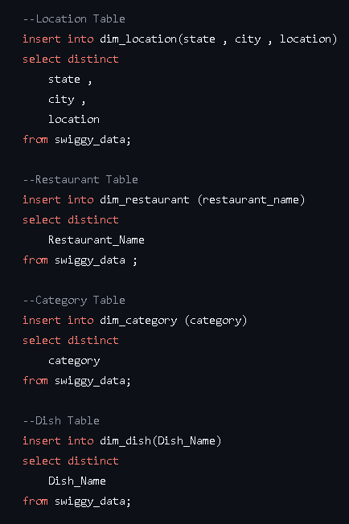
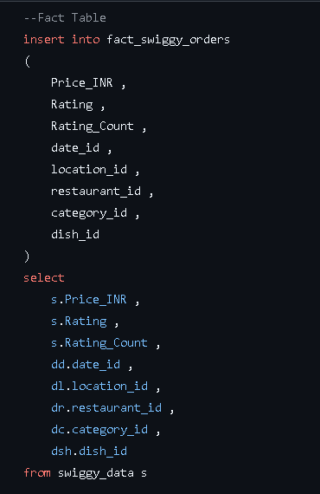
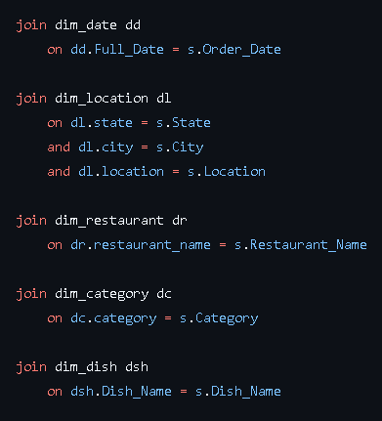
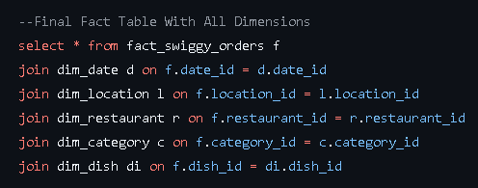
KPI Analysis :
Core KPIs:
Q1: What is the total number of orders?
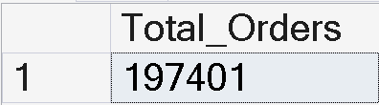
The platform recorded 197,401 total orders during the observed period.
Q2: What is the total revenue generated?
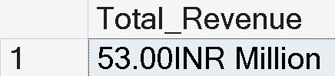
Total revenue generated is approximately ₹21 Million.
Q3: What is the average dish price?
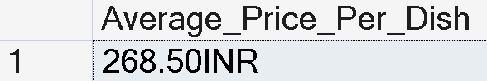
The average order value is ₹268.50.

Q4: What is the average rating?
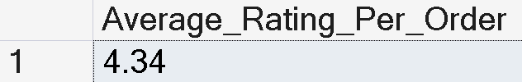
The overall customer rating stands at 4.34, indicating strong satisfaction.
Date-Based Analysis
Q5: How did orders perform month-wise?
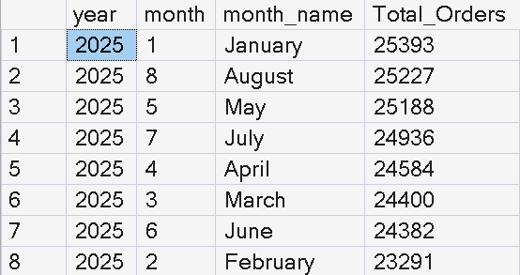
January recorded the highest orders, while February showed the lowest. Demand remains stable across months.
Q6: How did revenue perform month-wise?
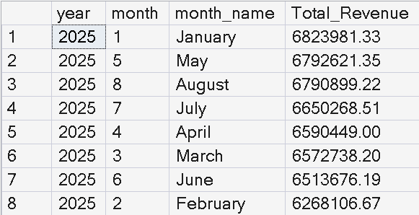
Revenue closely mirrors order trends with January leading performance.
Q7: How did performance vary quarterly?
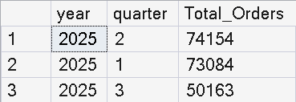
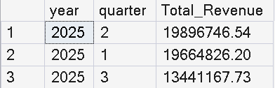
Q2 slightly outperformed Q1. Q3 is lower due to partial data availability.
Q8: What is the day-of-week order pattern?
Saturday is the highest-performing day. Weekend demand is slightly stronger than weekdays.
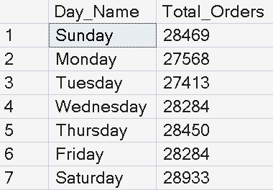

Location-Based Analysis
Q9: Which cities generate the highest orders?
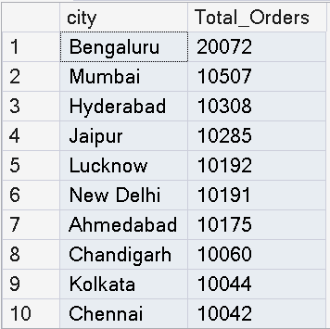
Bengaluru dominates with nearly double the volume of other cities.
Q10: Which states generate the highest revenue?
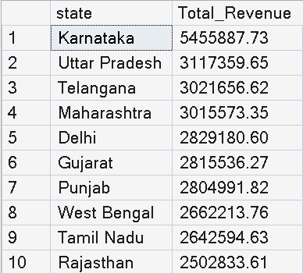
Karnataka leads state-level revenue contribution.

Food Performance Analysis
Q11: Which restaurants receive the highest orders?
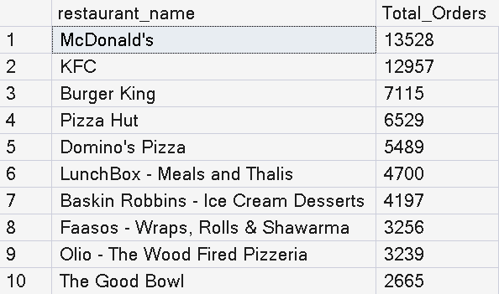
McDonald's and KFC dominate platform volume.
Q12: Which food categories perform best?
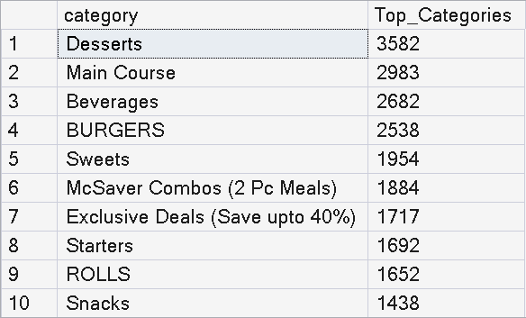
Desserts and Main Course categories generate the highest demand.

Q13: What are the most ordered dishes?
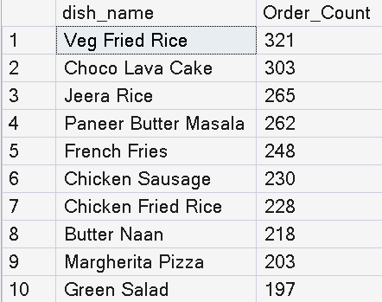
Veg Fried Rice and Choco Lava Cake are top-performing dishes.
Q14: How do cuisines perform in terms of orders and ratings?
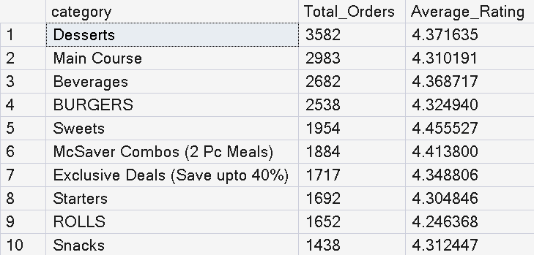
Top categories maintain strong ratings above 4.2, indicating quality consistency.

Customer Spending Insights
Q15: How are orders distributed across price ranges?
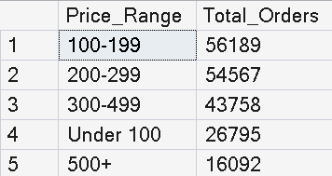
Majority of customers prefer mid-range pricing (₹100–299).
Ratings Analysis
Q16: How are ratings distributed?
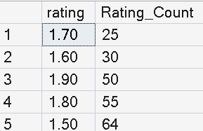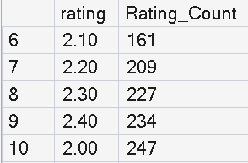
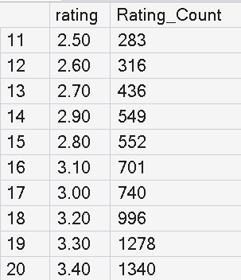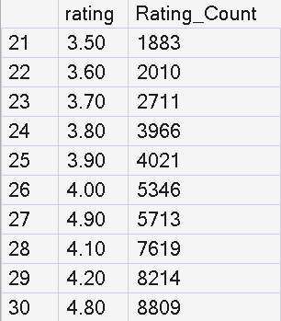
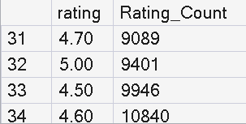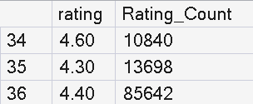

Ratings are heavily concentrated between 4.0–4.8, showing strong customer satisfaction.

Name: Dakshak Jagdheesh
Mail-ID: dakshakjagdheesh@gmail.com
Linked-in: https://www.linkedin.com/in/dakshak-jagdheesh-m
GitHub: https://github.com/Dj12012004

